**CLIMB HIGH**

**A PROJECT REPORT**

**Submitted by**

**SHREY SHARMA [Reg No:RA2211051010010]**

**Under the guidance of**

**Dr. RAJALAKSHMI D,**

**in partial fulfillment for the award of the degree**

**of**

**BACHELOR OF TECHNOLOGY**

**in**

**COMPUTER SCIENCE and ENGINEERING**

**with specialization in**

**GAMING TECHNOLOGY**

**Of**

**FACULTY OF ENGINEERING AND TECHNOLOGY**



**S.R.M. Nagar, Kattankulathur, Kanchipuram District**

**MAY 2024**

**ABSTRACT**

The Climb High game, a captivating 2D challenging platformer experience created in Unity, immerses players in the thrilling role of playing a plant which needs to reach the top. This abstract encapsulates the game's development process, methodology, and key findings. From hardware and software design considerations to implementation details and performance metrics, which provide insights into the game's creation. Innovative game play mechanics and level designing deliver an engaging and enraging user experience. Future enhancements aim to expand features and enhance player immersion. Embark on an exhilarating journey to the top with the Climb High game in Unity.

**ACKNOWLEDGEMENT**

We express our heartfelt thanks to our honorable Vice Chancellor

Dr. C. MUTHAMIZHCHELVAN, for being the beacon in all our endeavors.

We would like to express my warmth of gratitude to our Registrar

Dr. S. Ponnusamy, for his encouragement.

We express our profound gratitude to our Dean (College of

Engineering and Technology) Dr. T. V. Gopal, for bringing out novelty in all executions.

We would like to express my heartfelt thanks to the Chairperson, School of Computing Dr. Revathi Venkataraman, for imparting confidence to complete my course project

We wish to express my sincere thanks to Course Audit Professors Dr. Vadivu. G , Professor, Department of Data Science and Business Systems and Dr. Sasikala. E Professor, Department of Data Science and Business Systems and Course Coordinators for their constant encouragement and support.

We are highly thankful to our my course project faculty, Rajalakshmi D , Professor at SRM ,DSBS, for her assistance, timely suggestion and guidance throughout the duration of this course project.

We extend my gratitude to our HoD & GT ; & lT ; Designation & GT;, & lT ;Department & GT; and my Departmental colleagues for their Support.

Finally, we thank our parents and friends near and dear who directly and indirectly contributed to the successful completion of our project . Above all, I thank the almighty for showering his blessings on me to complete my course project.

**INDEX**

*S.NO TITLE PAGE NO.*

1. INTRODUCTION 1-3

1.1 Brief discussion of the game

1.2 Literature Survey

2. METHADOLOGY 4-5

3. IMPLEMENTATION 6-8

3.1 Experimental Setups

3.2 Program logic for parameters

4. RESULTS AND DISCUSSION 9-13

5. CONCLUSION AND FUTURE PLANS 14

**INTRODUCTION**

Welcome to the Climb High Game, a challenging 2D experience designed to ignite your anger and motivate you to reach the top! In this adrenaline-fueled journey, players take on the exhilarating role of playing a plant in a boot character through different themed platforms, each more breathtaking and challenging than the last. As you navigate to the top, you'll see multiple interactive platforms from which you can either take help or avoid, to reach the top. Whether you're a seasoned rage games player or a novice, the game's difficult gameplay and addictive challenges will keep you coming back for more or might make you uninstall the game itself. So buckle up and get ready to embark on the climb of a lifetime. The skies await your command in the Climb High game - where every moment is a pulse-pounding thrill ride!

*1.1 Brief description of the project*

The Climb High game is a captivating 2D challenging platformer experience developed in Unity. Players take control of a character and navigate to the top by climbing the platforms in beautifully pixelated environments. The game offers intuitive controls and addictive gameplay mechanics, providing an immersive journey. Players must showcase their skills and patience to reach the highest point possible. With future enhancements planned to expand features and enhance player immersion, the Climb High game promises an exhilarating adventure that will keep players engaged and enraged for hours on end.

*1.2 Literature Survey*

Platformer games are a genre of video games where the primary focus is on navigating characters through a series of levels or environments by jumping between platforms. The gameplay typically involves controlling a character who can jump, run, and sometimes perform other actions like climbing, swimming, or fighting enemies. The goal is usually to reach the end of the level or to complete specific objectives while avoiding obstacles, hazards, and enemies along the way. Here are some key findings from the literature survey:

**Gameplay Design Principles:**

Research has highlighted the importance of intuitive controls, dynamic level generation or design , and balanced difficulty progression in platformer games. Studies suggest that well-designed levels with a mix of obstacles and power-ups contribute to player engagement and retention.

**Player Engagement Strategies:**

Studies have examined different player engagement techniques employed in platformer games, such as reward systems, achievement mechanisms, and social integration features. These strategies aim to enhance player motivation and prolong gameplay sessions.

**Technological Advancements:**

Research has explored the role of technological advancements, such as procedural generation algorithms and real-time physics simulations, in shaping the gameplay experience of platformer games. These advancements enable developers to create dynamic and immersive environments that adapt to player actions.

**User Experience Design:**

Literature has emphasized the importance of user experience design in platformer games, focusing on aspects such as interface layout, visual aesthetics, and sound design. Studies suggest that a well-crafted user experience enhances player immersion and enjoyment.

**Impact of Platformer Games on Health and Well-being:**

Some research has investigated the potential health benefits of playing platformer games, such as improving cognitive function like, reflexes, problem solving etc, and sometimes also reducing stress levels.

Overall, the literature survey underscores the significance of platformer games as a popular and engaging genre that continues to evolve with advancements in technology and design methodologies. By understanding the underlying principles and player preferences, developers can create compelling platformer games that captivate audiences and provide memorable gaming experiences.

**METHADOLOGY**

The development of the Climb High game involved a structured approach that encompassed several key stages, each contributing to the overall design, implementation, and testing of the game. Here's an overview of the methodology employed in creating it:

**Conceptualization:**

The initial phase involved conceptualizing the game idea and defining its core features, gameplay mechanics, and target audience. Brainstorming sessions and market research helped identify popular trends in the rage filled platformer genre and determine unique selling points for the game.

**Design Planning:**

Once the concept was finalized, the next step was to plan the game's design architecture, including its graphical assets, level layout, user interface elements, and sound effects. Design documents and mockups were created to visualize the game's aesthetics and user experience.

**Development Tools Selection:**

The choice of development tools played a crucial role in the implementation of the game. Unity, a popular game engine, was selected for its versatility, ease of use, and robust feature set. Additional software tools, such as graphic design software and audio editing tools, were also employed.

**Prototyping:**

Prototyping involved creating a basic version of the game to test its core mechanics and gameplay loop. This iterative process allowed for rapid iteration and refinement of gameplay features, ensuring a polished experience before full-scale development.

**Art Asset Creation:**

The creation of art assets involved designing and producing visuals for the game, including character sprites, background elements, obstacles, and special effects. A cohesive art style was maintained to ensure visual consistency and enhance the game's aesthetic appeal.

**Programming Implementation:**

The programming phase focused on implementing the game's functionality, including player controls, and user interface interactions. Object-oriented programming principles were employed to maintain code modularity and flexibility.

**Testing and Debugging:**

Throughout the development process, extensive testing and debugging were conducted to identify and resolve any bugs, glitches, or gameplay imbalances. Both manual testing and automated testing tools were utilized to ensure the game's stability and performance across different devices.

**Feedback and Iteration:**

Feedback from play testers and beta users played a crucial role in refining the game's design and addressing any usability issues or gameplay concerns. Iterative updates were released based on user feedback, with continuous improvement efforts aimed at enhancing the overall player experience.

**IMPLEMENTATION**

*3.1 Experimental Setups*

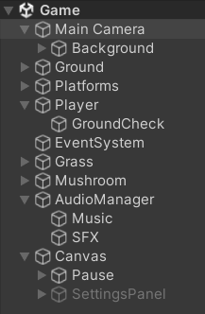 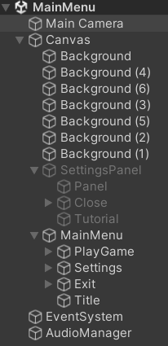

*3.2 Program logic for parameters*

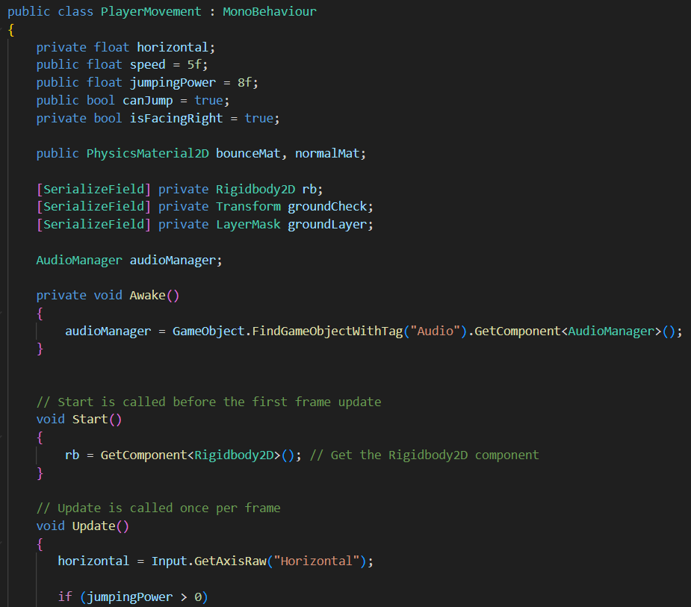

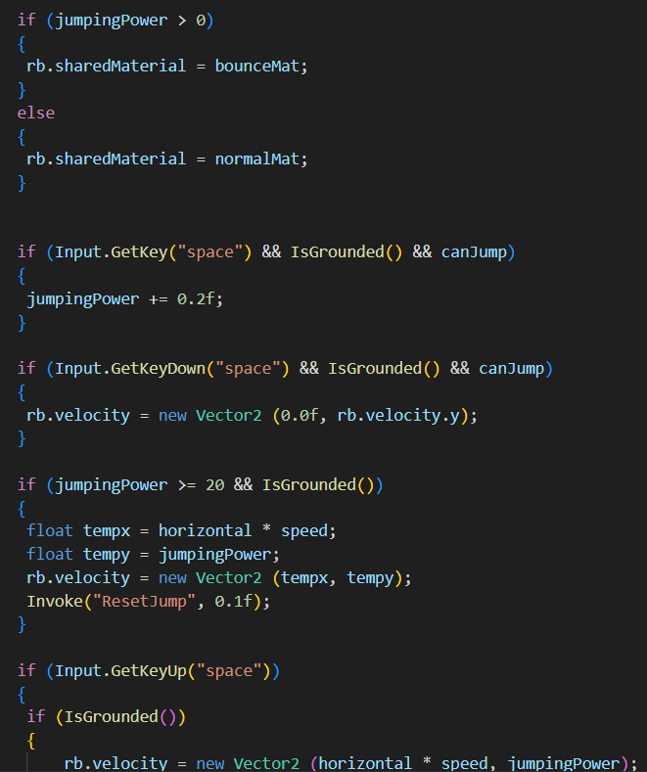

***RESULTS AND DISCUSSION***

**MAIN MENU**

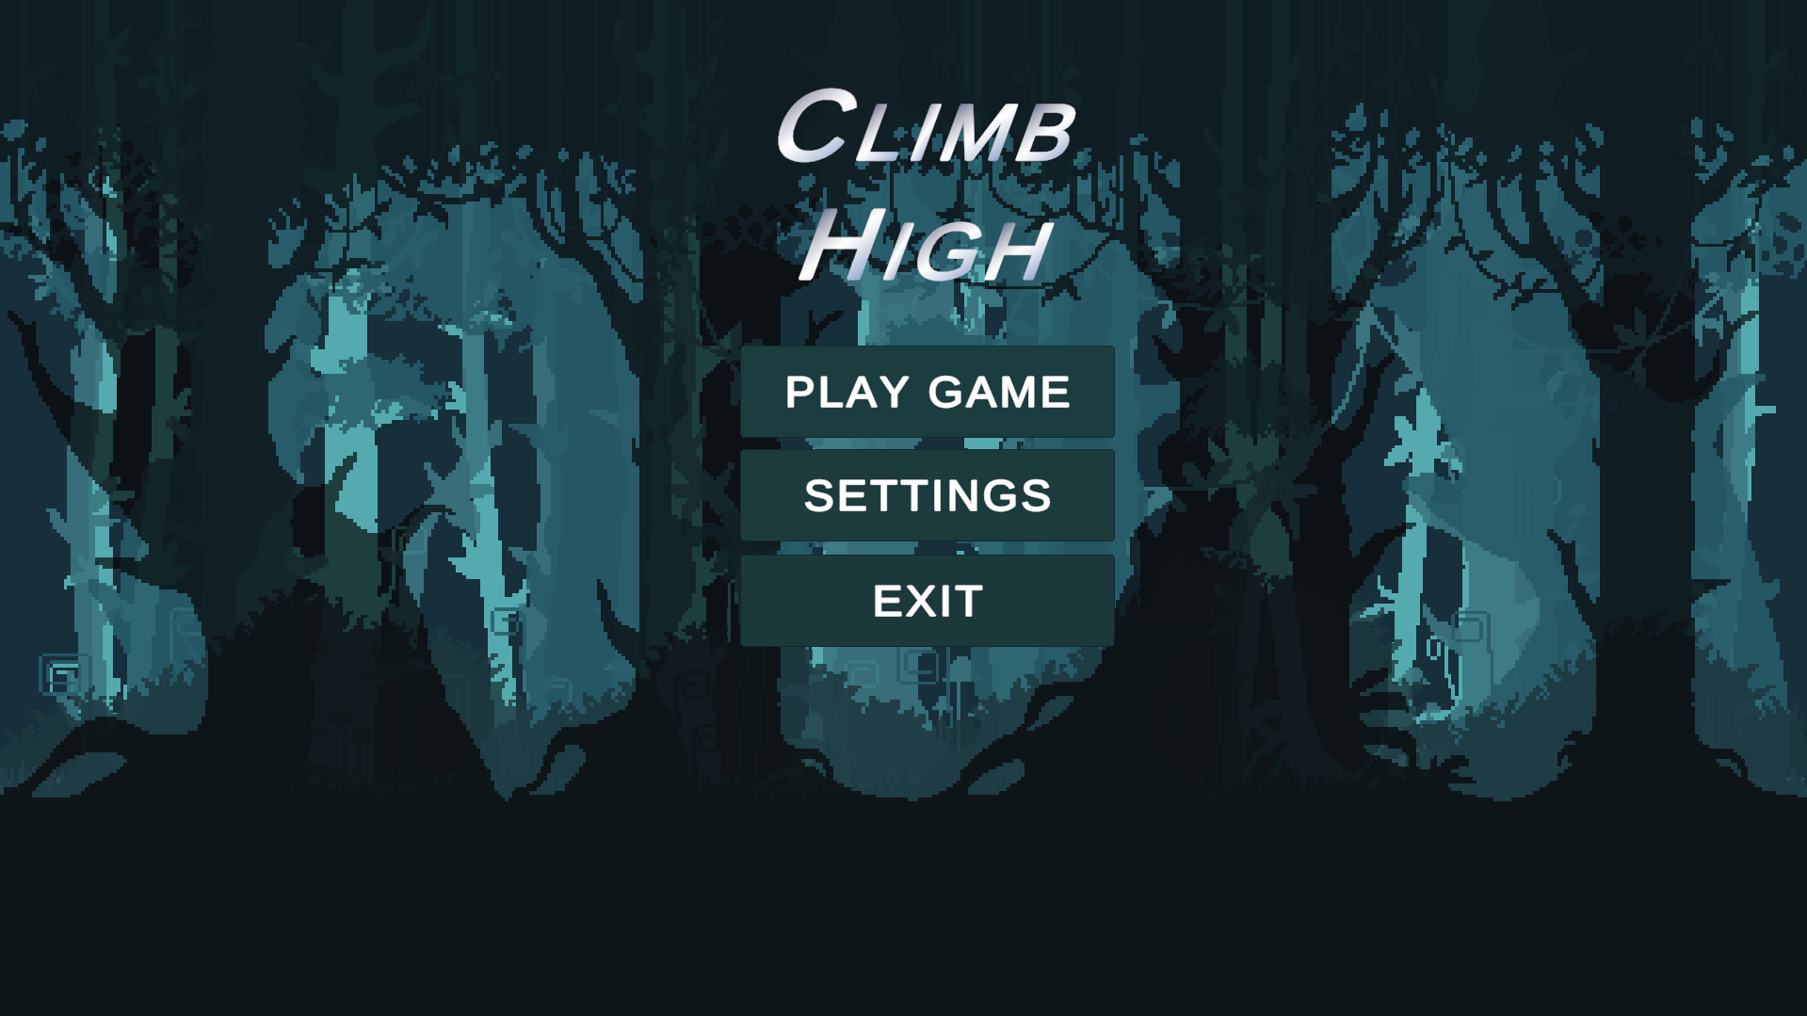

**SETTINGS**

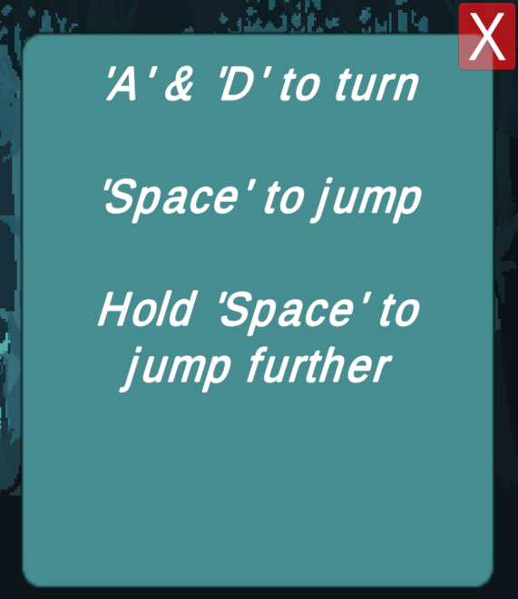 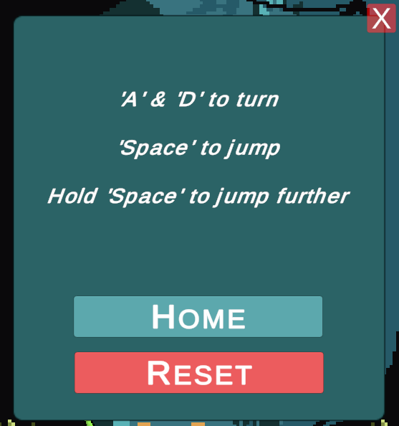

**ASSETS**

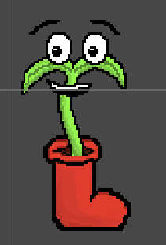 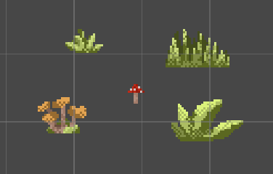

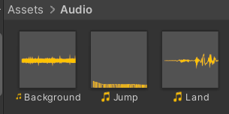

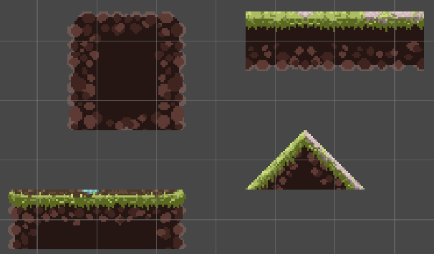

**LEVEL DESIGN**

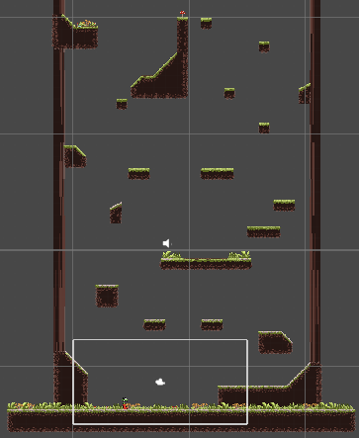

**PLAYER VIEW**

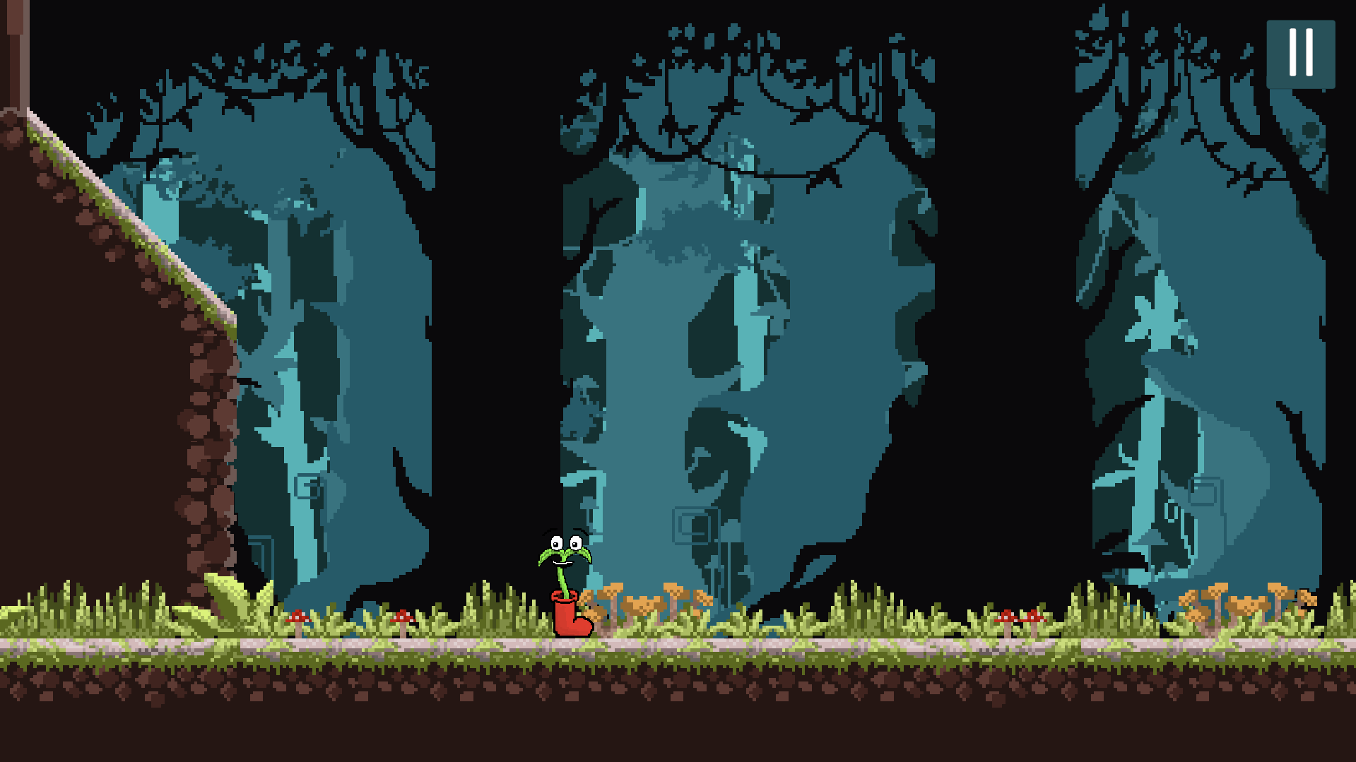

**GAME PLAY**

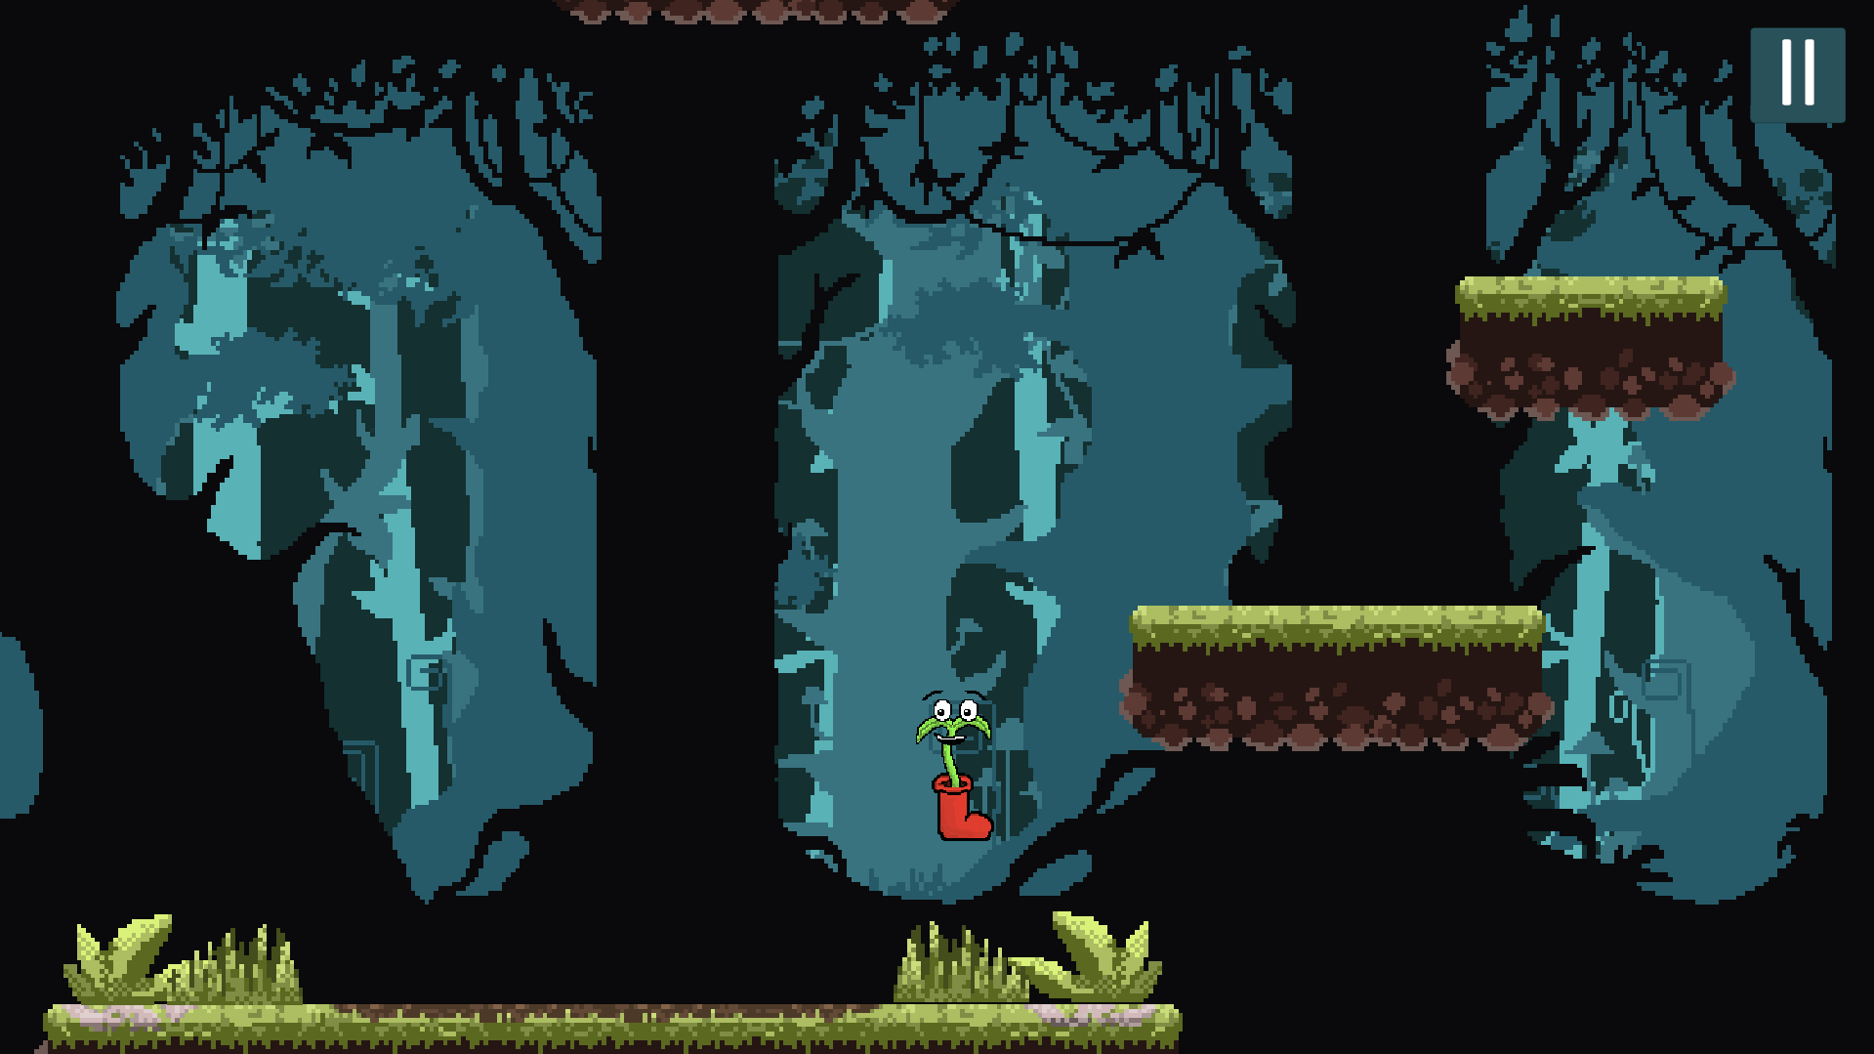

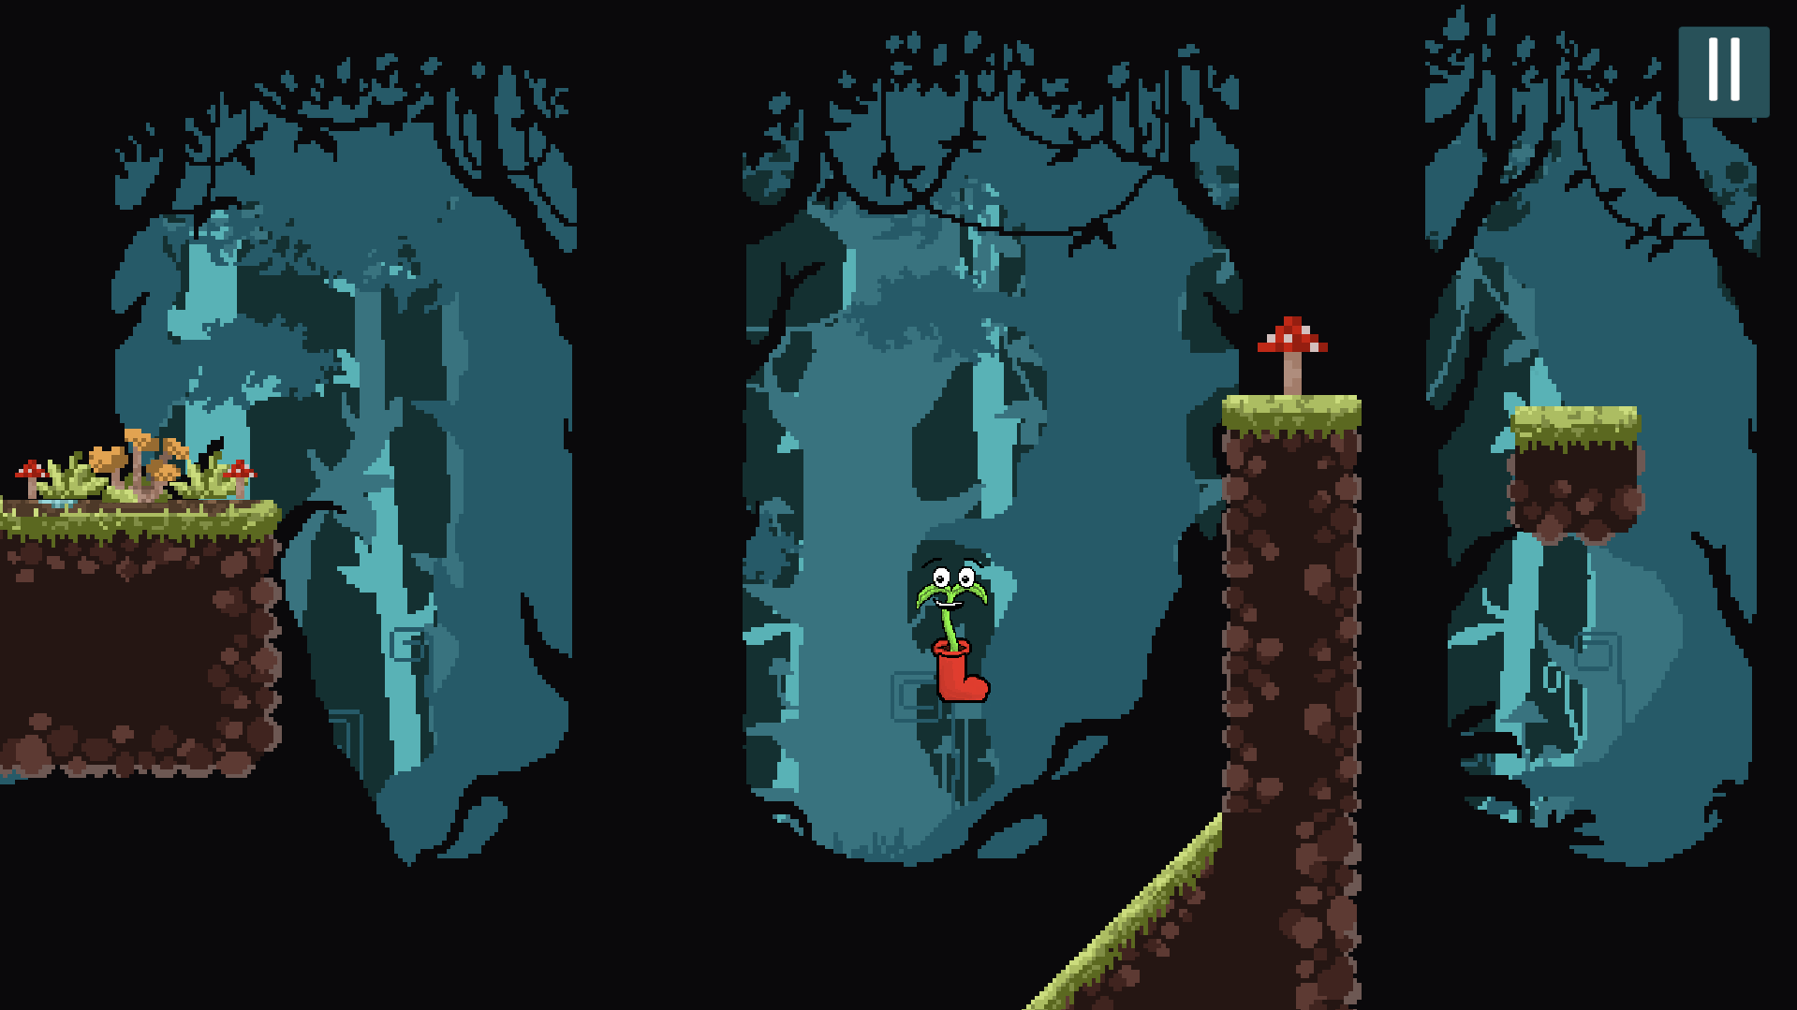

**GAME ENDINGS**

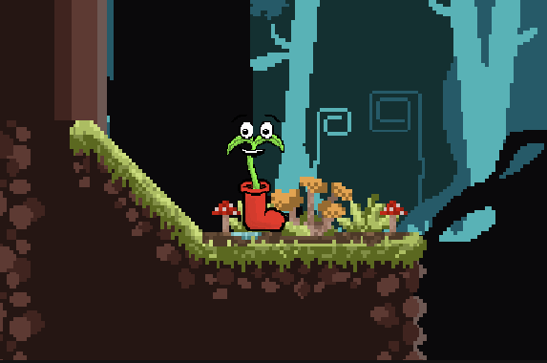

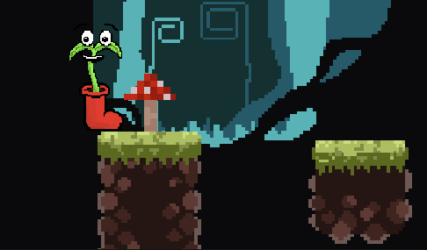**CONCLUSION AND FUTURE PLANS**

1. *New Environments:* Introducing new levels with unique themes and environments, ranging from lush forests and icy tundra to hot deserts.
2. *Additional Characters Customization:* Adding a variety of ways to customize your characters for players to unlock.
3. *Power-Ups and Upgrades:* Introducing new power-ups, upgrades, and special abilities to enhance gameplay and provide players with strategic options for overcoming challenges.
4. *Multiplayer Mode:* Implementing a multiplayer mode that allows players to compete against friends or other players online in thrilling races and challenges.
5. *Community Engagement:* Engaging with the player community to gather feedback, suggestions, and ideas for further improving the game and ensuring that it remains a beloved favorite among players.

By continuing to innovate, iterate, and listening to player feedback, the Climb High game will evolve into an even more immersive, exciting, and memorable gaming experience that brings joy and anger to players around the world. The sky's the limit for the future of the Climb High game!

**Roles :-**

*Shrey Sharma :*  Game Design, Level Design, Scripting, Sound Design